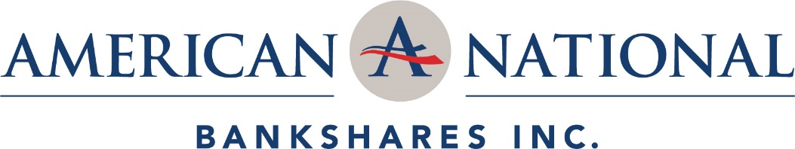

American National Bankshares Inc. Announces the Hiring of Cynthia Vogler as New Market President

For more information, contact:

Jeffrey V. Haley Carolyn B. Kiser
President & Chief Executive Officer SVP, Director of Marketing & Community Affairs
American National Bankshares Inc. American National Bank & Trust Company
haleyj@amnb.com kiserc@amnb.com
434.773.2259 540.278.1703

FOR IMMEDIATE RELEASE:
DANVILLE, VA, January 15, 2020 – American National Bankshares Inc. (NASDAQ: AMNB), parent company (the Company) of American National Bank and Trust Company (the Bank) announced today the hiring of Cynthia Vogler (Cindy) as a Senior Vice President of the Bank and Triangle Market President, to include Raleigh, Cary, Durham and Chapel Hill.
President and Chief Executive Officer Jeffrey V. Haley remarked, "As we start this year, we are very pleased to be expanding into a vibrant market by bringing Cindy Vogler along with a strong banking team to American National. Cindy’s knowledge and more than 35 years of banking experience will certainly help us grow in this key market.” Prior to coming to American National, she was Area Manager, Client Advisory for Pinnacle Bank. A resident of Cary, North Carolina with a degree from UNC-Chapel Hill, Cindy is well suited to lead a team of local bankers.
Vogler stated, "It is a privilege for me to join American National Bank and Trust Company. I’m excited to be part of a growing, community bank and continue my career with a bank that can handle the banking needs of larger customers, but that still maintains a community focus. Staying connected to the local community is important to me.” With a history of serving area non-profit organizations, Vogler currently serves on the Salvation Army Advisory Board of Wake County as well as Operation Coming Home.
Haley added, "In addition to hiring Cindy as Market President, she has helped assemble a team of Triangle-area bankers and we are excited to have them all on board. We will apply with the OCC to open a full-service branch.”

About American National Bankshares Inc.
American National is a multi-state bank holding company with total assets of approximately $2.5 billion. Headquartered in Danville, Virginia, American National is the parent company of American National Bank and Trust Company. American National Bank is a community bank serving Virginia and North Carolina with 26 banking offices. American National Bank also manages an additional $855 million of trust, investment and brokerage assets in its Trust and Investment Services Division. Additional information about the company and the bank is available on the bank's website at www.amnb.com.

